**EMERGENCY ASTHMA PLAN FOR SCHOOLS**

**Asthma Attack**

For children diagnosed with Asthma/Wheeze

**SIGNS OF :**

* **Wheezing**
* **Coughing**
* 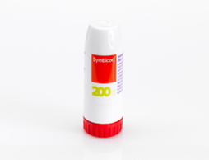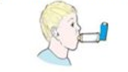**Shortness of Breath**

Number of puffs needed of **BLUE** inhaler:

6- 10 PUFFS

**OR**

You can take up to 6 inhalations of your **MART** device.

Tell a member of staff

Parents to be called and child to be collected and seen by medical professional the same day.

If little or no improvement after 10 puffs of BLUE inhaler:

**Dial 999**

Continue to give **BLUE** inhaler 10 PUFFS every 15 minutes until medical help arrives or symptoms improve.

**OR**

If you have taken 6 inhalations of your **MART** device and your symptoms have not improved or used your maximum daily inhalations, seek urgent help.

Number of puffs needed of **BLUE** inhaler :

2- 6 PUFFS

**OR**

Number of inhalations needed of your **MART** device:

Take 1 inhalation of your **MART** device, wait a few minutes and repeat if necessary, up to a total of 6 inhalations.

Tell a member of staff

If better no further action required

**Treatment**

GIVE UP TO 10 PUFFS OF RELIEVER (BLUE) INHALER

**OR**

UP TO 6 INHALATIONS OF MART (WHITE AND RED) TURBOHALER AT A SINGLE TIME

**\*\*\*If their own RESCUE inhaler is NOT AVAILABLE, please use the school’s emergency inhaler kit \*\*\***