EMERGENCY ASTHMA PLAN FOR SCHOOLS
Asthma Attack
For children diagnosed with Asthma/Wheeze

SIGNS OF :
- Wheezing
- Coughing
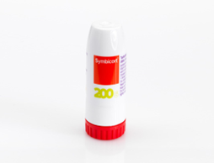
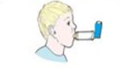
- Shortness of Breath
Number of puffs needed of BLUE inhaler:
6- 10 PUFFS
OR
You can take up to 6 inhalations of your MART device.
Tell a member of staff
Parents to be called and child to be collected and seen by medical professional the same day.

If little or no improvement after 10 puffs of BLUE inhaler:
Dial 999
Continue to give BLUE inhaler 10 PUFFS every 15 minutes until medical help arrives or symptoms improve.
OR
If you have taken 6 inhalations of your MART device and your symptoms have not improved or used your maximum daily inhalations, seek urgent help.
Number of puffs needed of BLUE inhaler :
2- 6 PUFFS
OR
Number of inhalations needed of your MART device:
Take 1 inhalation of your MART device, wait a few minutes and repeat if necessary, up to a total of 6 inhalations.
Tell a member of staff
If better no further action required

Treatment
GIVE UP TO 10 PUFFS OF RELIEVER (BLUE) INHALER
OR
UP TO 6 INHALATIONS OF MART (WHITE AND RED) TURBOHALER AT A SINGLE TIME

***If their own RESCUE inhaler is NOT AVAILABLE, please use the school’s emergency inhaler kit ***

