**School Asthma Policy**

School Name .........................................................................................................

Headteacher/Principal...........................................................................................

Asthma Lead..........................................................................................................

School Nursing team .............................................................................................

**Asthma**

Asthma is a condition that affects small tubes (airways) that carry air in and out of the lungs. When a person with asthma comes into contact with something that irritates their airways (an asthma trigger), the muscles around the walls of the airways tighten so that the airways become narrower, and the lining of the airways becomes inflamed and starts to swell. Sometimes, sticky mucus or phlegm builds up, which can further narrow the airways. These reactions make it difficult to breathe, leading to symptoms of asthma (Source: Asthma UK)

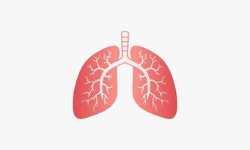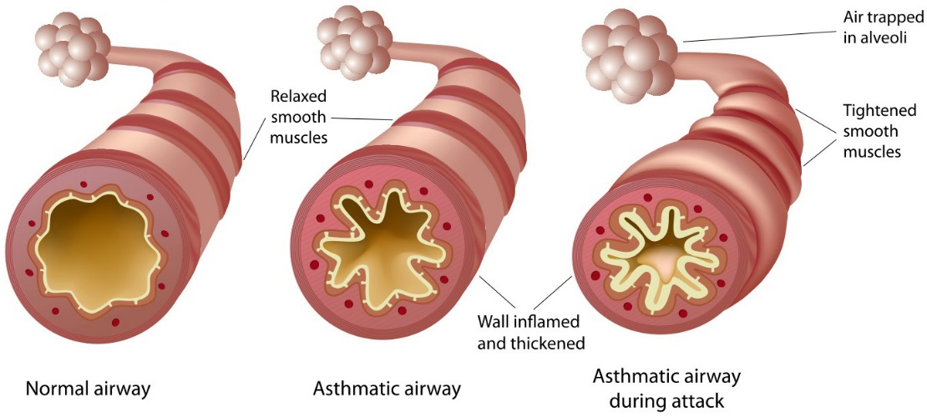

As a school, we recognise that asthma is a widespread, serious, but controllable condition. This school welcomes all pupils with asthma and aims to support these children in participating fully in school life. We endeavour to do this by ensuring we have:

* an asthma register
* up-to-date asthma policy,
* an asthma lead,
* all pupils with immediate access to their reliever inhaler at all times,
* all pupils have an up-to-date asthma action plan,
* an emergency salbutamol inhaler
* ensure all staff have regular asthma training,
* promote asthma awareness pupils, parents and staff

**Asthma Register**

We have an asthma register of children within the school, which we update yearly. We do this by asking parents/carers if their child is diagnosed as asthmatic or has been prescribed a reliever inhaler. When parents/carers have confirmed that their child is asthmatic or has been prescribed a reliever inhaler we ensure that the pupil has been added to the asthma register and has:

• an up-to-date copy of their personal asthma action plan,

• their reliever (salbutamol/terbutaline) inhaler and a spacer in school,

• permission from the parents/carers to use the emergency salbutamol inhaler if they require it and their own inhaler is broken, out of date, empty or has been lost.

**Asthma Lead**

This school has an asthma lead who is named above. It is the responsibility of the asthma lead to manage the asthma register, update the asthma policy, manage the emergency salbutamol inhalers (please refer to the Department of Health Guidance on the use of emergency salbutamol inhalers in schools, March 2015) ensure measures are in place so that children have immediate access to their inhalers.

**Medication and Inhalers**

All children with asthma should have immediate access to their reliever (usually blue) inhaler at all times. The reliever inhaler is a fast-acting medication that opens up the airways and makes it easier for the child to breathe. (Source: Asthma UK).

Some children will also have a preventer inhaler, which is usually taken morning and night, as prescribed by the doctor/nurse. This medication needs to be taken regularly for maximum benefit. Children should not bring their preventer inhaler to school as it should be taken regularly as prescribed by their doctor/nurse at home. However, if the pupil is going on a residential trip, we are aware that they will need to take the inhaler with them so they can continue taking their inhaler as prescribed. (Source: Asthma UK)

Children are encouraged to carry their reliever inhaler as soon as they are responsible enough to do so. We would expect this to be by key stage 2. However, we will discuss this with each child’s parent/carer and teacher. We recognise that all children may still need supervision in taking their inhaler.

For Younger children, reliever inhalers are kept in the classroom in ___________________ on __________________ .

School staff are not required to administer asthma medicines to pupils however many children have poor inhaler technique or are unable to take the inhaler by themselves. Failure to receive their medication could end in hospitalisation or even death. Staff who have had asthma training and are happy to support children as they use their inhaler, can be essential for the well-being of the child. If we have any concerns over a child’s ability to use their inhaler, we will refer them to the school nurse and advise parents/carers to arrange a review with their GP/nurse. Please refer to the medicines policy for further details about administering medicines. (Source: Asthma UK)

**Asthma Action Plans**

Asthma UK evidence shows that if someone with asthma uses personal asthma action plan they are four times less likely to be admitted to hospital due to their asthma. As a school, we recognise that having to attend hospital can cause stress for a family. Therefore, we believe it is essential that all children with asthma have a personal asthma action plan to ensure asthma is managed effectively within school to prevent hospital admissions. (Source: Asthma UK).

**Staff training**

Staff will need yearly asthma updates. This training can be provided by the school nursing team or accessed online via Education for Health [Supporting Children's Health and Young People with Asthma (educationforhealth.org)](https://www.educationforhealth.org/course/supporting-children-and-young-peoples-health-improving-asthma-care-together/). We aim to ensure a minimum of 85% of staff complete this.

**School Environment**

The school does all that it can to ensure the school environment is favourable to pupils with asthma. The school has a definitive no-smoking policy. Pupil’s asthma triggers will be recorded as part of their asthma action plans and the school will ensure, where possible, that pupils will not come into contact with their triggers.

We are aware that triggers can include:

* Colds and infection
* Dust and house dust mite
* Pollen, spores and moulds
* Feathers
* Furry animals
* Exercise, laughing
* Stress
* Cold air, change in the weather
* Chemicals, glue, paint, aerosols
* Food allergies
* Fumes and cigarette smoke (Source: Asthma UK)

As part of our responsibility to ensure all children are kept safe within the school grounds and on trips away, a risk assessment will be performed by staff. These risk assessments will establish asthma triggers which the children could be exposed to and plans will be put in place to ensure these triggers are avoided, where possible.

**Exercise and activity**

Taking part in sports, games and activities is an essential part of school life for all pupils. All staff will know which children in their class have asthma and all PE teachers at the school will be aware of which pupils have asthma from the school’s asthma register. (Source: Asthma UK)

Pupils with asthma are encouraged to participate fully in all activities. It is agreed with PE staff that pupils who are mature enough will carry their inhaler with them and those that are too young will have their inhaler labelled and kept in a box at the site of the lesson. If a pupil needs to use their inhaler during a lesson, they will be encouraged to do so. (Source: Asthma UK)

**When asthma is affecting a pupil’s education**

The school are aware that the aim of asthma medication is to allow people with asthma to live a normal life. Therefore, if we recognise that if asthma is impacting on their life a pupil, and they are unable to take part in activities, tired during the day, or falling behind in lessons we will discuss this with parents/carers, the school nurse, with consent, and suggest they make an appointment with their asthma nurse/doctor. It may simply be that the pupil needs an asthma review, to review inhaler technique, medication review or an updated Personal Asthma Action Plan, to improve their symptoms. However, the school recognises that Pupils with asthma could be classed as having disability due to their asthma as defined by the Equality Act 2010, and therefore may have additional needs because of their asthma.

**Emergency Salbutamol Inhaler in school**

As a school we are aware of the guidance ‘The use of emergency salbutamol inhalers in schools from the Department of Health’ (March, 2015) which gives guidance on the use of emergency salbutamol inhalers in schools (March, 2015).

We have _____ emergency kit(s), which are kept in the ________________________, _______________ and _________________ so it is easy to access.

Each kit contains:

* A salbutamol metered dose inhaler;
* At least two spacers compatible with the inhaler;
* Instructions on using the inhaler and spacer;
* Instruction on cleaning and storing the inhaler;
* Manufacturer’s information;
* A checklist of inhalers, identified by their batch number and expiry date, with monthly checks recorded;
* A note of the arrangements for replacing the inhaler and spacers;
* A list of children permitted to use the emergency inhaler:
* A record of administration

We understand that salbutamol is a relatively safe medicine, particularly if inhaled, but all medicines can have some adverse effects. Those of inhaled salbutamol are well known, tend to be mild and temporary are not likely to cause serious harm. The child may feel a bit shaky or may tremble, or they may say that they feel their heart is beating faster.

We will ensure that the emergency salbutamol inhaler is only used by children who have asthma or who have been prescribed a reliever inhaler, and for whom written parental consent has been given. The school’s asthma lead and team will ensure that:

* On a monthly basis the inhaler and spacers are present and in working order, and the inhaler has sufficient number of doses available.
* replacement inhalers are obtained when expiry dates approach.
* The plastic inhaler housing (which holds the canister) has been cleaned, dried, and returned to storage following use, or that replacements are available if necessary.

Before using a salbutamol inhaler for the first time, or if it has not been used for 2 weeks or more, shake and release 2 puffs of medicine into the air.

Any puffs should be documented so that it can be monitored when the inhaler is running out. The inhaler has _________ puffs, so when it gets to _______ puffs having been used we will replace it.

The spacer can be reused, after each use it will be dismantled and washed in hot soapy water using a soft cloth, it will be left to air dry then reassembled. The inhaler can also be reused. Following use, the inhaler canister will be removed, and the plastic inhaler housing and cap will be washed in warm running water, and left to dry in air in a clean safe place. The canister will be returned to the housing when dry and the cap replaced.

Spent inhalers will be returned to the pharmacy to be recycled.

The emergency salbutamol inhaler will only be used by children:

* Who have been diagnosed with asthma and prescribed a reliever inhaler
* OR who have been prescribed a reliever inhaler
* **AND** for whom written parental consent for use of the emergency inhaler has been given.

The name(s) of these children will be clearly written in our emergency kit(s). The parents/carers will always be informed in writing if their child has used the emergency inhaler, so that this information can also be passed onto the GP.

**Common ‘day to day’ symptoms of asthma**

As a school we require that children with asthma have a personal asthma action plan which can be provided by their doctor / nurse. These plans inform us of the day-to-day symptoms of each child’s asthma and how to respond to them in an individual basis. We will also send home our own information and consent form for every child with asthma each school year. This needs to be returned immediately and kept with our asthma register. However, we also recognise that some of the most common day-to-day symptoms of asthma are:

* Dry cough
* wheeze (a ‘whistle’ heard on breathing out) often when exercising
* Shortness of breath when exposed to a trigger or exercising
* Tight chest

These symptoms are usually responsive to the use of the child’s inhaler and rest (e.g. stopping exercise). As per DOH document; they would not usually require the child to be sent home from school or to need urgent medical attention

**Asthma Attacks**

The school recognises that if all of the above is in place, we should be able to support pupils with their asthma and hopefully prevent them from having an asthma attack. However, we are prepared to deal with asthma attacks should they occur. All staff will receive an asthma update annually, and as part of this training, they are taught how to recognise an asthma attack and how to manage an asthma attack. In addition, guidance will be displayed in all classrooms and common areas.

The department of health Guidance on the use of emergency salbutamol inhalers in schools (March 2015) states the signs of an asthma attack are:

• Persistent cough   
• A wheezing sound coming from the chest   
• Difficulty breathing (the child could be breathing fast and with effort, using all accessory muscles in the upper body)  
• Nasal flaring   
• Unable to talk or complete sentences. Some children will go very quiet   
• May try to tell you that their chest ‘feels tight’ (younger children may express this as tummy ache)

If the child is showing these symptoms, we will follow the guidance for responding to an asthma attack recorded below.

However, we also recognise that we need to call an ambulance immediately and commence the asthma attack procedure without delay if the child:

*Appears exhausted   
*is going blue   
*Has a blue/white tinge around lips   
*has collapsed

**It goes on to explain that in the event of an asthma attack:**

• Keep calm and reassure the child   
• Encourage the child to sit up and slightly forward   
• Use the child’s own inhaler – if not available, use the emergency inhaler   
• Remain with the child while the inhaler and spacer are brought to them   
• *Shake the inhaler and remove the cap   
• *Place the mouthpiece between the lips with a good deal, or place the mask securely over the nose and mouth   
• *Immediately help the child to take two puffs of salbutamol via the spacer, one at a time.(1 puff to 5 breaths)   
• If there is no improvement, repeat these steps* up to a maximum of 10 puffs   
• Stay calm and reassure the child. Stay with the child until they feel better. The child can return to school activities when they feel better.   
• If you have had to treat a child for an asthma attack in school, it is important that we inform the parents/carers and advise that they should make an appointment with the GP   
• If the child has had to use 6 puffs or more in 4 hours the parents should be made aware and they should be seen by their doctor/nurse.   
• If the child does not feel better or you are worried at ANYTIME before you have reached 10 puffs, call 999 FOR AN AMBULANCE and call for parents/carers.   
• If an ambulance does not arrive in 10 minutes give another 10 puffs in the same way   
• A member of staff will always accompany a child taken to hospital by an ambulance and stay with them until a parent or carer arrives

**References**

• Asthma UK website (2015)   
• Asthma UK (2006) School Policy Guidelines.   
• BTS/SIGN asthma Guideline   
• Department of Health (2014) Guidance on the use of emergency salbutamol inhaler in schools