Given current increased rates in the community of Group A Streptococcus and admissions with invasive Group A Streptococcal iGAS) complications guidance below is in line with **UKHSA advice and** [SCAN antibiotic guidance](https://viewer.microguide.global/SCAN/SCAN#content,155abd57-83c4-41b3-89fa-3ed84a4724e7) **until rates decrease.**

1. **Reduced threshold for antibiotics**
2. **Antibiotic choices if supply shortage**
3. **When to take a swab**
4. **Notify the local health protection team promptly within 3 days by completing a**[**notification form**](https://www.gov.uk/government/publications/notifiable-diseases-form-for-registered-medical-practitioners)**if a diagnosis of scarlet fever is suspected.**
5. **Clear Safety netting for early detection of streptococcal complications** [**Scarlet Fever (Group A Strep) :: Frimley HealthierTogether (frimley-healthiertogether.nhs.uk)**](https://frimley-healthiertogether.nhs.uk/parentscarers/worried-your-child-unwell/scarlet-fever)
6. [**Clear Safety netting**](https://frimley-healthiertogether.nhs.uk/professionals/safety-netting-documents-parents/bronchiolitis) **for those not prescribed antibiotics**
7. [**Isolation guidelines**](https://frimley-healthiertogether.nhs.uk/parentscarers/child-unwell-ok-go-nurseryschool) **for schools and nurseries**
8. **Referral guidance to secondary care** 
   1. **If meet criteria as per** [**fever pathway**](https://frimley-healthiertogether.nhs.uk/application/files/1116/3595/1996/NHS_Fever_Pathway_Primary_and_Community_Care_TBC.pdf_MAy_21_2_1.pdf) **OR**
   2. **Signs of iGAS OR**
   3. **Signs of post streptococcal complications**

**Group A Streptococcus presents with:**

1. Prodromal symptoms: if seen at this stage safety netting is key
2. Sore throat
3. Fever
4. Painful cervical lymphadenopathy
5. Strawberry tongue
6. Scarlet rash: the rash begins with papular lesions on the body that then spread to the neck and arms over 1-2 days. The rash is often accentuated in flexural creases but tends to spare the palms and soles of the feet.

The rash is not pruritic but has a characteristic sand-paper feel to it. The rash does not appear on the face, but the cheeks can look red. The redness may be harder to see on [brown and black skin](https://dftbskindeep.com/all-diagnoses/scarlet-fever/).

**If the child only has a runny nose, cough or diarrhoea, without the other signs they are unlikely to have scarlet fever.**

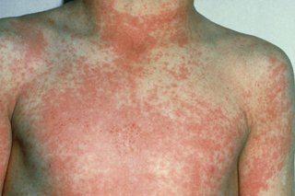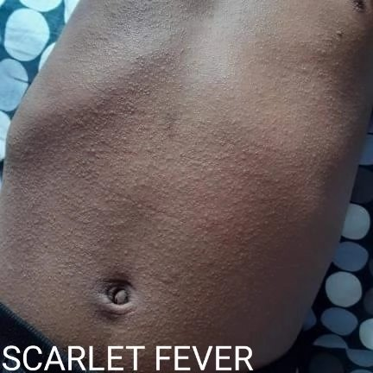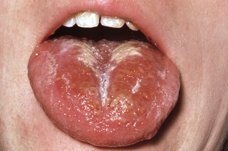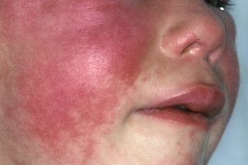

**Complications are iGAS**

1. Sepsis
2. Streptococcal pneumonia
3. Lymphadenitis
4. Cellulitis, necrotizing fasciitis, and streptococcal toxic shock syndrome
5. Endocarditis, septic arthritis, osteomyelitis and liver abscess
6. Meningitis and cerebral abscess
7. Mastoiditis, peritonsillar abscess

**Children who have recently had chickenpox or influenza are more likely to develop more serious infections.**

**Post complications include:**

1. Acute post-streptococcal glomerulonephritis (typically 2 or more weeks after the acute infection)
2. Acute rheumatic fever with endocarditis and reactive arthritis
3. **Reduced threshold for antibiotics**

**TONSILIITS**

Most young children presenting with tonsillitis have a viral aetiology. No significant difference in pain score at day 3 in children treated with antibiotics compared to those treated with placebo. Antibiotic NNT greater than 4000 to prevent one case of quinsy.

**Optimise management of pain** - regular paracetamol or ibuprofen for pain (right dose for age or weight at the right time and maximum doses for severe pain).1,2

Base decision about antibiotic treatment on **FeverPAIN**1,2 score (1 point for each of fever, purulence, attend within 3 days of onset or less, severely Inflamed tonsils, no cough or coryza):

* **Score 0-1:** less than 20% likelihood of isolating streptococcus: use **NO** antibiotics
* **Score 2:** 20-40% likelihood of isolating streptococcus, use **back up/delayed** antibiotic OR **NO** antibiotic
* **Score 3 or more:** over 40% likelihood of isolating streptococcus, use **immediate** antibiotic

Score validated in children 3 years and over - younger children are less likely to have a bacterial aetiology and are less likely to develop complications.

*(7/12/22: The scores have been updated in light of increased Invasive Group A Strep incidence and deviate from NICE guidance)*

**SCARLET FEVER:**

All require antibiotic treatment as below.

1. **Antibiotic choice for potential Group A Strep infections**

If you are unable to access amoxicillin suspension consider if the patient can swallow capsules (signpost parent/carer to the [pill swallowing information on the Healthier Together website).](https://frimley-healthiertogether.nhs.uk/parentscarers/teaching-your-child-swallow-tablets)If swallowing capsules is not possible use an alternative including **cefalexin suspension** (as per [BNFc BD dosing](https://bnfc.nice.org.uk/drugs/cefalexin/" \l "indications-and-dose)) or **co-amoxiclav** suspension ([as per BNFc dosing](https://bnfc.nice.org.uk/drugs/co-amoxiclav/#indications-and-dose)).

Note phenoxymethylpenicillin liquid is unpalatable and poorly tolerated by children.

[**Updated SCAN Guidelines**](https://viewer.microguide.global/SCAN/SCAN#content,0f684166-f5cf-437d-97b2-38a4cefbd3b1)**:**

**For children unable to swallow tablets  (see note above if amoxicillin suspension unavailable)**

**Amoxicillin** for **7** days1

40mg/kg po BD4 (max 1g per dose) (off-label)

Or by age:

**3-11 months:**125mg po TDS2 or 250mg po BD4 (off-label)

**1-4 years:**250mg po TDS2 or 500mg po BD4 (off-label)

**5-11 years:**500mg po TDS2 or 750mg po BD4 (off-label)

**12 years** **and over:**500mg po TDS2 or 1g po BD4 (off-label)

**OR**

**Phenoxymethylpenicillin (Penicillin V)**for**7**days1,3 **Note: The unpleasant taste and palatability of Phenoxymethylpenicillin (Penicillin V) suspension can affect adherence to antibiotics, which may result in treatment failure.**

**1-11 months**: 125mg po BD2

**1-5 years:** 250mg po BD2

**6-11 years:** 500mg po BD2

**12-17 years:** 1g po BD2

**For children able to swallow tablets**

**Phenoxymethylpenicillin (Penicillin V)** tablets for**7**days1,3

**6-11 years:** 500mg po BD2  
**12-17 years:** 1g po BD2

**If allergic to penicillin**

**Clarithromycin**2,3for**5**days3

**Under 8 kg:** 7.5 mg/kg po BD2

**8-11 kg:** 62.5mg po BD2

**12-19 kg:** 125mg po BD2

**20-29 kg:** 187.5mg po BD2

**30-40 kg**: 250mg po BD2

**12-17 years:** 250-500mg po BD2

**OR**

**Erythromycin (if pregnant)**for**5**days

**8-17 years:** 1g po BD2

**Cautions**

Aim to use an antibiotic that minimises dosing frequency and is palatable (if suspension prescribed)to optimise adherence.

**References**

1. NICE CKS. Scarlet fever. Last revised 03/20. Accessed [LINK](https://cks.nice.org.uk/topics/scarlet-fever/) 11/21
2. BNFc accessed at [LINK](https://bnfc.nice.org.uk/) 12/21
3. NICE & PHE. Summary of antimicrobial prescribing guidance – managing common infections [LINK](https://www.bnf.org/wp-content/uploads/2021/07/summary-antimicrobial-prescribing-guidance_july-21-for-BNF.pdf) accessed 12/21
4. WHO - Recommendations for management of common childhood 2012 conditions. [LINK](http://apps.who.int/iris/bitstream/handle/10665/44774/9789241502825_eng.pdf;jsessionid=4A4F6A5C1B6502FE62D4FBF828312C96?sequence=1) accessed 11/21

**Last updated**

7/12/22 Added link to  UKHSA - Urgent public health message: Invasive Group A Strep 2/12/22  statement added re alternatives where amoxicillin suspension is unavailable.

1. **Consider taking a throat swab to assist with differential diagnosis or if the patient is thought to be part of an outbreak (to confirm aetiology), allergic to penicillin (to determine antimicrobial susceptibility) or in regular contact with vulnerable individuals**
2. **Notify the local health protection team promptly within 3 days by completing a**[**notification form**](https://www.gov.uk/government/publications/notifiable-diseases-form-for-registered-medical-practitioners)**if a diagnosis of scarlet fever is suspected.**
3. **Clear Safety netting for early detection of streptococcal complications** [**Scarlet Fever (Group A Strep) :: Frimley HealthierTogether (frimley-healthiertogether.nhs.uk)**](https://frimley-healthiertogether.nhs.uk/parentscarers/worried-your-child-unwell/scarlet-fever)
4. [**Clear Safety netting**](https://frimley-healthiertogether.nhs.uk/professionals/safety-netting-documents-parents/bronchiolitis) **for those not prescribed antibiotics**
5. [**Isolation guidelines**](https://frimley-healthiertogether.nhs.uk/parentscarers/child-unwell-ok-go-nurseryschool) **for schools and nurseries**

Advise the family to keep child away from school/nursery for 1 day after starting antibiotic treatment, wash their hands frequently, avoid sharing eating utensils and towels, dispose of tissues promptly, and avoid contact with anyone at particular risk of infection (e.g. people with valvular disease or who are immunocompromised).

1. **Referral guidance to secondary care** 
   1. **If meet criteria as per** [**Fever Pathway**](https://frimley-healthiertogether.nhs.uk/application/files/1116/3595/1996/NHS_Fever_Pathway_Primary_and_Community_Care_TBC.pdf_MAy_21_2_1.pdf) ***OR***
   2. **Signs of iGAS *OR***
   3. **Signs of post streptococcal complications**