

Paediatric Department
Frimley Park Hospital

Skin Prick Testing

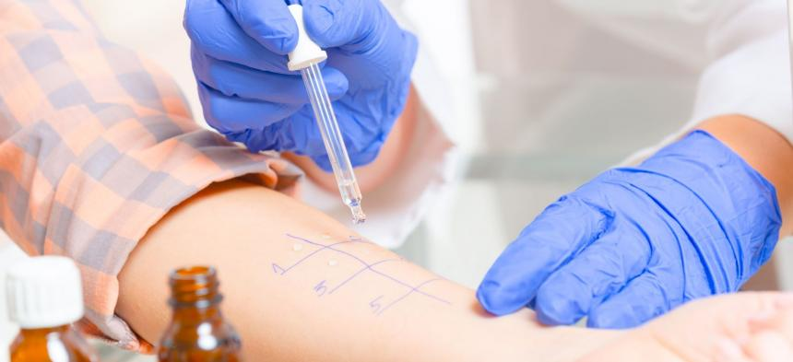

Information for patients, relatives and carers

Introduction

A Health Professional may request a skin prick test (SPT). This leaflet helps explain what the test involves. If you require further information please ask a staff member caring for you or your child.

What is a Skin Prick Test

A skin prick test (SPT) is a simple and safe method to help diagnose a suspected allergy. The test can help identify which specific allergen (the substance that causes an allergic reaction) your child may be allergic to. A trained specialist will place a droplet of the specific allergens to your child’s skin (usually to the forearm). A small pinprick is then made to the skin so the allergen is introduced under skin’s surface. This method may also be performed with food you have brought in from home if the allergy specialist has requested this specific food. Markings with a washable pen will also be made to your child’s forearm in order to identify the different allergens.

After 15 minutes, your child will be reviewed to check for a reaction. If your child has a positive reaction, the skin will become red and itchy with a raised swelling (weal). This means that its likely your child is allergic to the substance. A negative reaction is determined by the skin remaining normal.

How to prepare for a Skin Prick Test

If your child is taking antihistamines such as chlorphenamine (piriton), Cetirizine (Zirtek), Loratadine (Clarityn. Please stop taking these prior to the test as they may interfere with the results. Short acting antihistmaines (usually taken 2-3 times a day) such as chlorphenamine (piriton) must be stopped 48hours prior to the test. If your child takes long-acting antihistmaines (usually taken daily) such as cetirizine (Zirtek) or Loratadine (Clarityn) then these must be stopped 5 days prior to the test.

Please if your child has an allergic reaction prior to their appointment, administer medications if you need to.

What are the risks of a SPT?

A SPT is widely practiced and carries very low risk of serious side effects. Typical reactions are localised itching and swelling to the test site. Occasioanlly your child can feel dizzy or light headed. The medical team will be able to assist and treat this if it occurs. Severe allergic reactions are extremely rare, however the required medications to treat this will be readily available during your appointment. If the medical team are concerned your child is unwell due to the SPT they may ask you to remain in the departament for observation. The SPT should not be performed if your child is wheezy. Please contact the team if you are unsure on if you should attend ?

What happens after the test?

The results of the test will be considered along with your child’s clinical history. The nurse, consultant or dietician who specialises in allergy will discuss the results with you and what they mean. Your GP will also be informed of the test results.

After care following a Skin Prick Test

If your child becomes uncomfortable at the test site, you can use a cold compress or ice pack to relieve the area. An antihistamine medication can also be given. If you are concerned your child is unwell once you have left the hospital. Please contact your GP or go to your local Emergency Department immediately if concerned.

Contact Us

If you require any further information or have concerns about the skin prick test please contact us. If your child is unable to attend the appointment or has worsening allergy and asthma symptoms please inform us prior to the appointment.

Paediatric Allergy Nurse 01276 526625
Children’s Ward (F1) 01276 604226
Email: fhftchildallergy@nhs.net
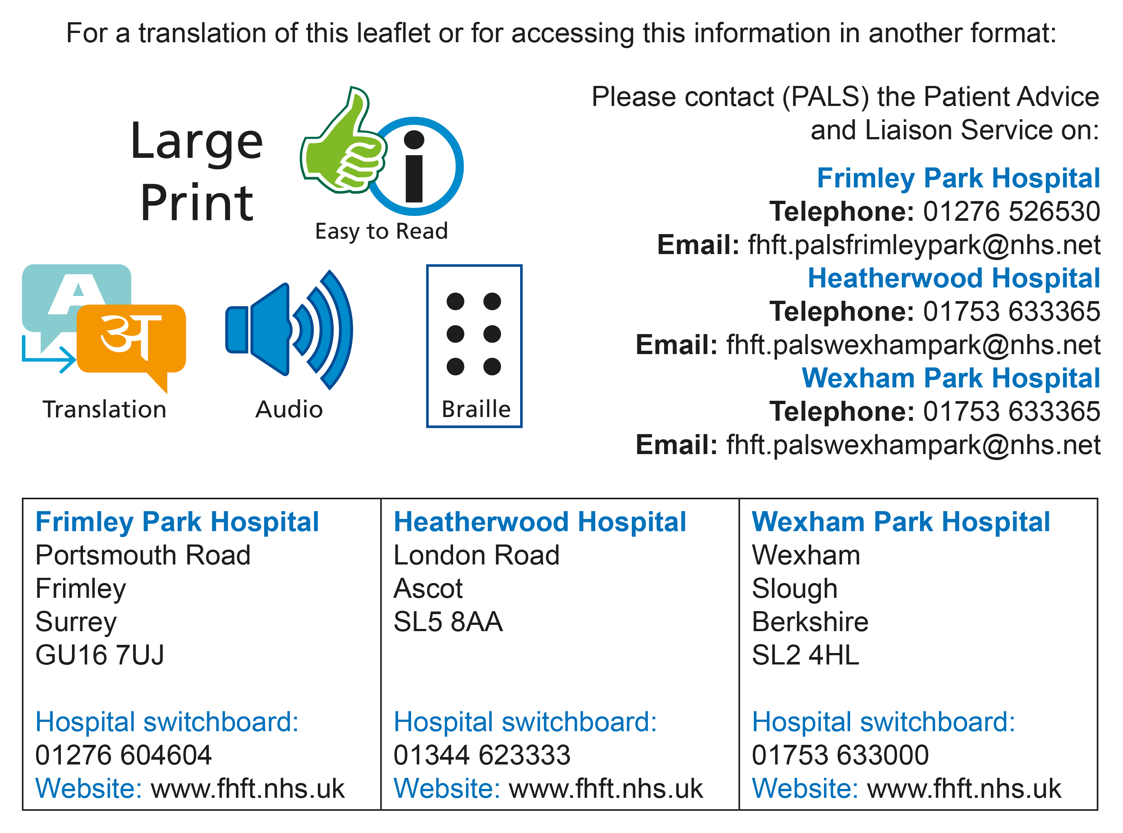

Title of Leaflet | Skin Prick Testing
Author | Hayley Whatmore |  | Department | Paediatrics
Ref. No |  | Issue Date |  | Review Date

Legal Notice
Please remember that this leaflet is intended as general information only. We aim to make the information as up to date and accurate as possible. Please therefore always check specific advice or any concerns you may have with your doctor.

